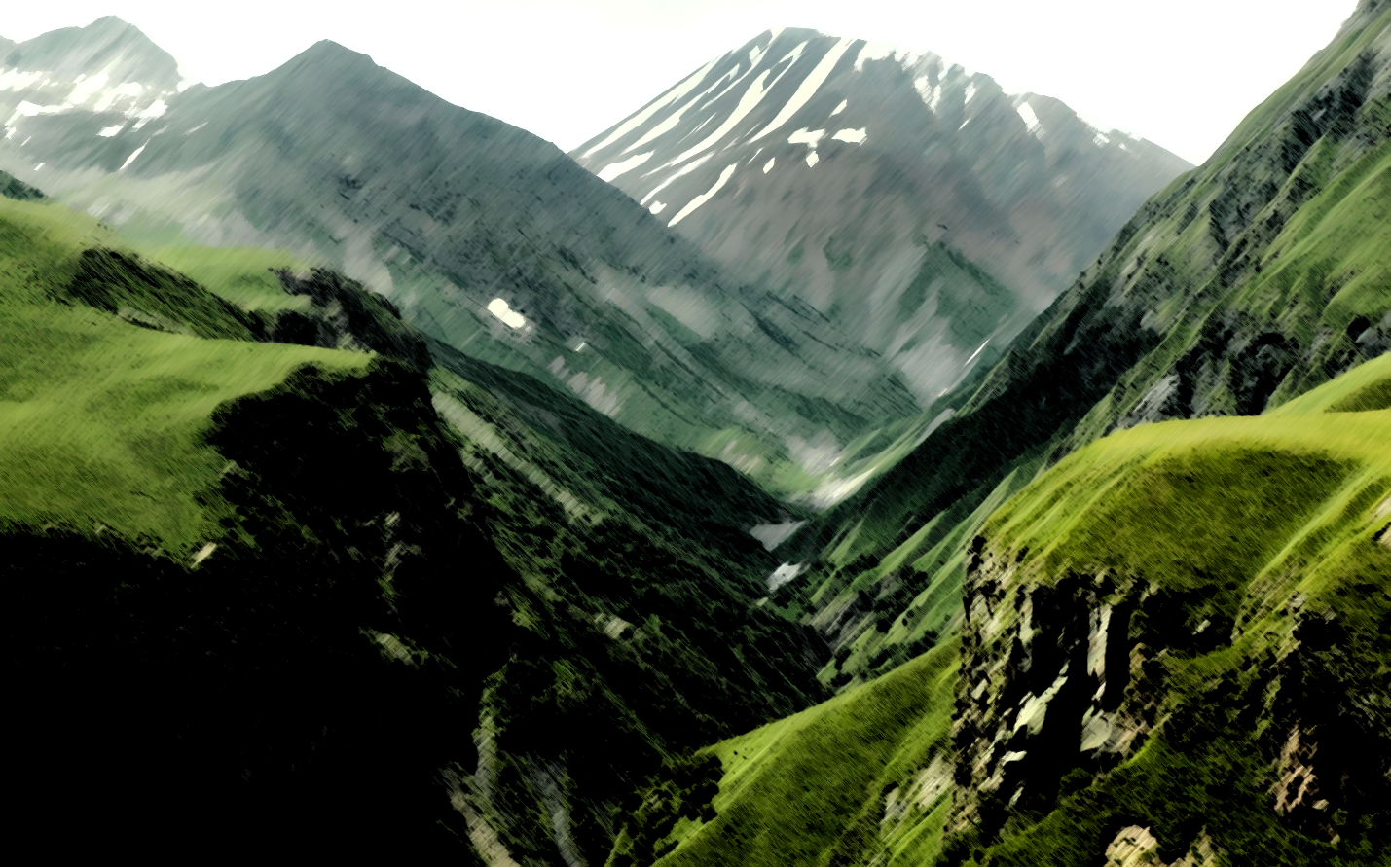

David Houston

EE 225 Lab 4

Bruce Barnes

The Fourier Valley

# Abstract

This lab aimed at analyzing the process of converting temporal functions in to Fourier space via the Fast Fourier Transform. We took and created the

# Introduction

The following processes were performed via MATLAB and LT Spice in order to further solidify the concepts of Fourier with respect to its series and transform representations in frequency space.

# Procedure

## Fourier series

To first analyze the Fourier series we manipulated a GUI file in order to see how the series representation of a temporal function responded.

The first analysis that was taken was to look at the response of a square wave function. It can see from the below graph that as the number of coefficients increases the accuracy of the wave shape does also. For the square wave it seems as though you need at least 15 coefficients in order for the wave shape to have a relatively close shape.

However, when you analyze the triangle wave form it can be seen that only need 4 coefficients in order to produce a similar wave shape, making this particular signal easier to produce.

The Sawtooth (or ramp function) wave needs a high amount of coefficients in order to produce a wave which models the desired form due to its non-sinusoidal shape.

In comparison, when examining the Half-Rectified Sine wave it can be seen that due to its relative phase and shape it is much easier to reproduce this function using the Fourier series as opposed to a square wave.

Now, the Full-Rectified Sine Wave, unlike its ugly step-sister, is much more complicated and unique therefore requiring more coefficients in order to full produce the desired waveform.

After fully analyzing the effects of the Fourier series of different temporal response systems, we created a MATLAB file to analyze an exponential time dependent response. The phase and magnitude plots were as follows

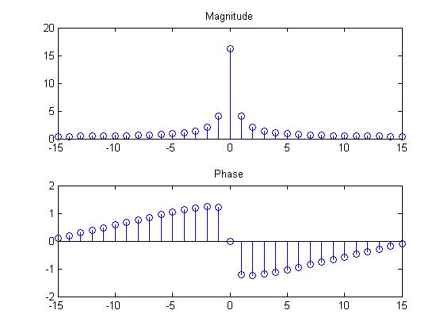

## Fourier Transform

In order to fully understand how to utilize the Fast Fourier Transform in MATLAB we analyzed four piecewise linear functions and their transforms.

The first piecewise function we analyzed consisted of a ramp function that leveled off at t=0 and then turned off at t=1. The Fourier transform reveled the following phase and magnitude graphs.

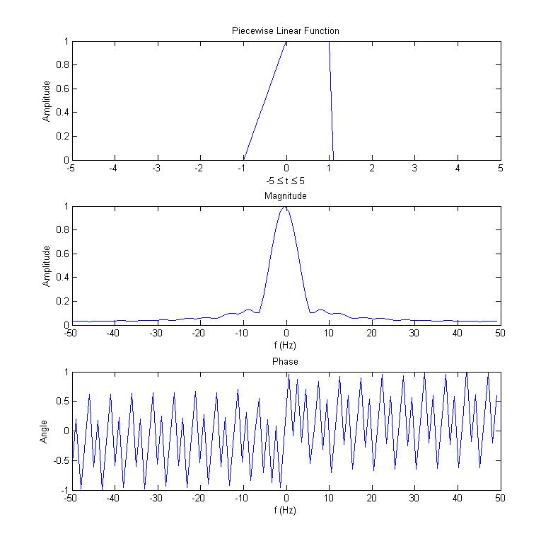

The second piecewise function is just like the first one except it is shifted to the right by a 1 time step. This justifiably results in a change in the phase of the system.

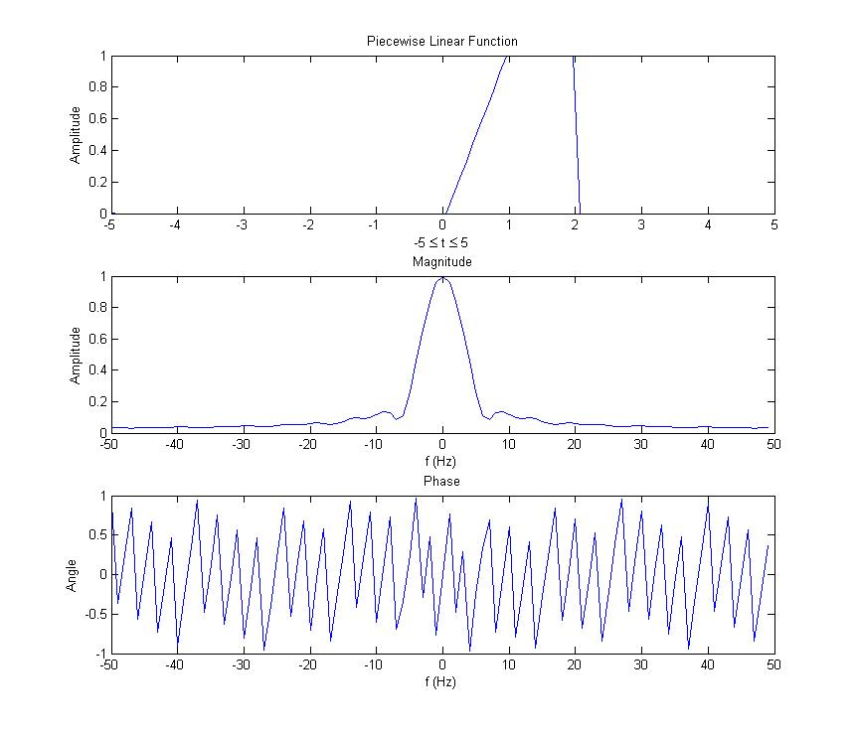

The next two piecewise functions are based off of a modification of the unitary step function. It can be seen that both the magnitude and phase change dramatically when the interval over which the system is active changes. 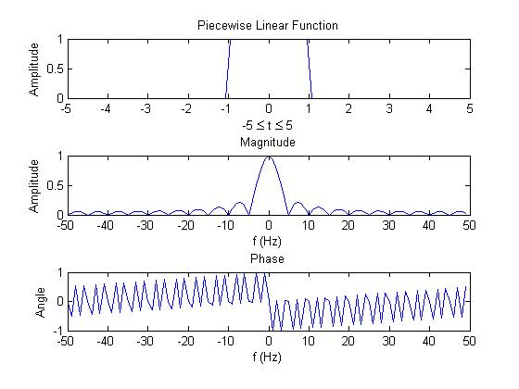

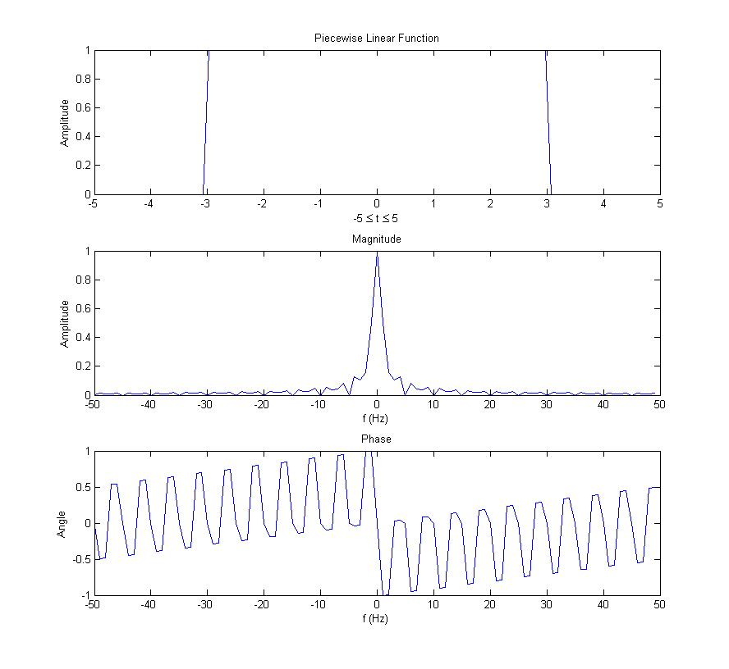

## Circuit Analysis

The a

# Appendix A

## Square Wave

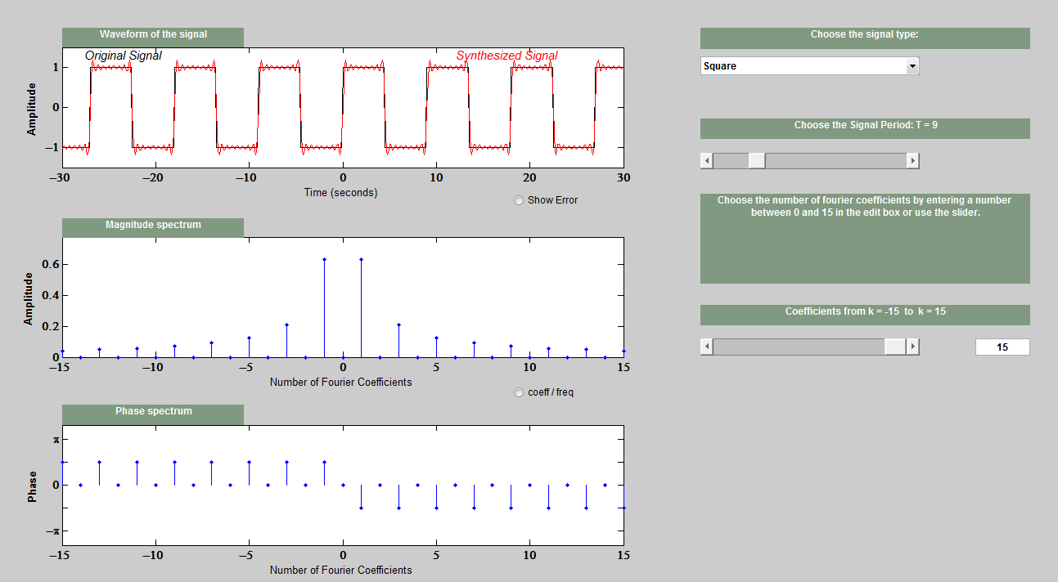

## Triangle Wave

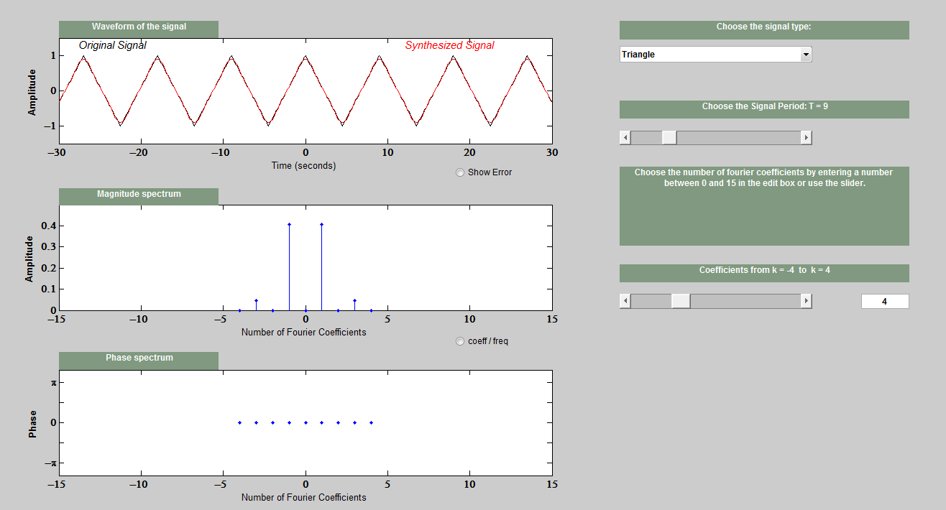

## Sawtooth Wave

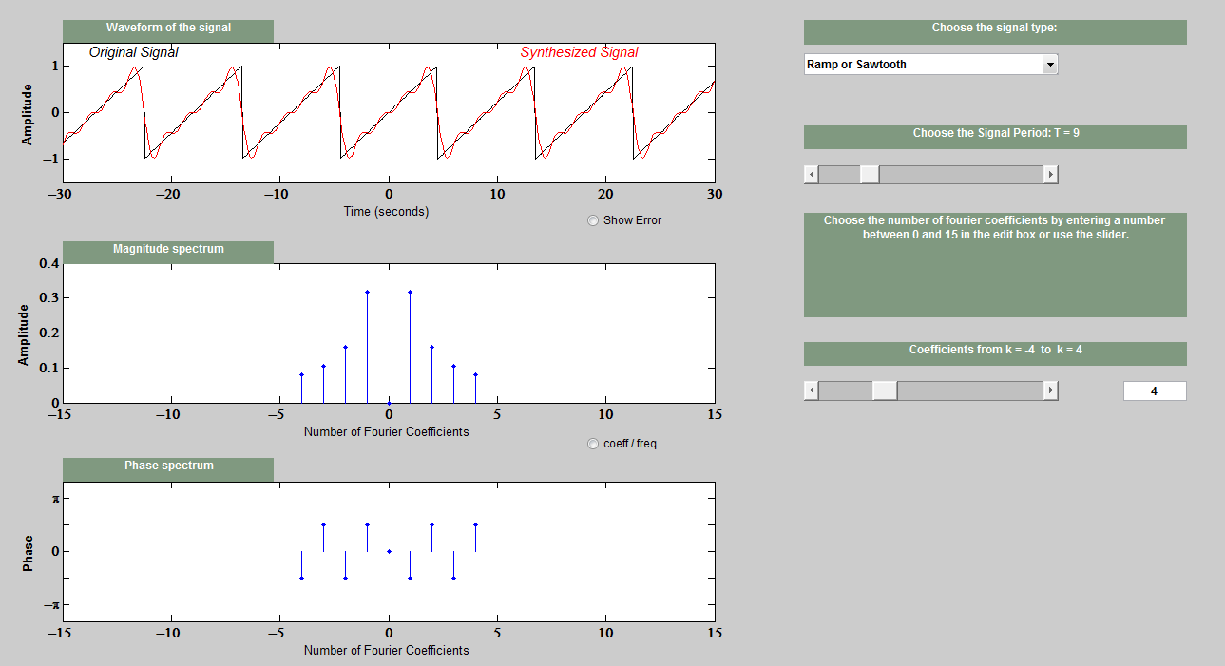

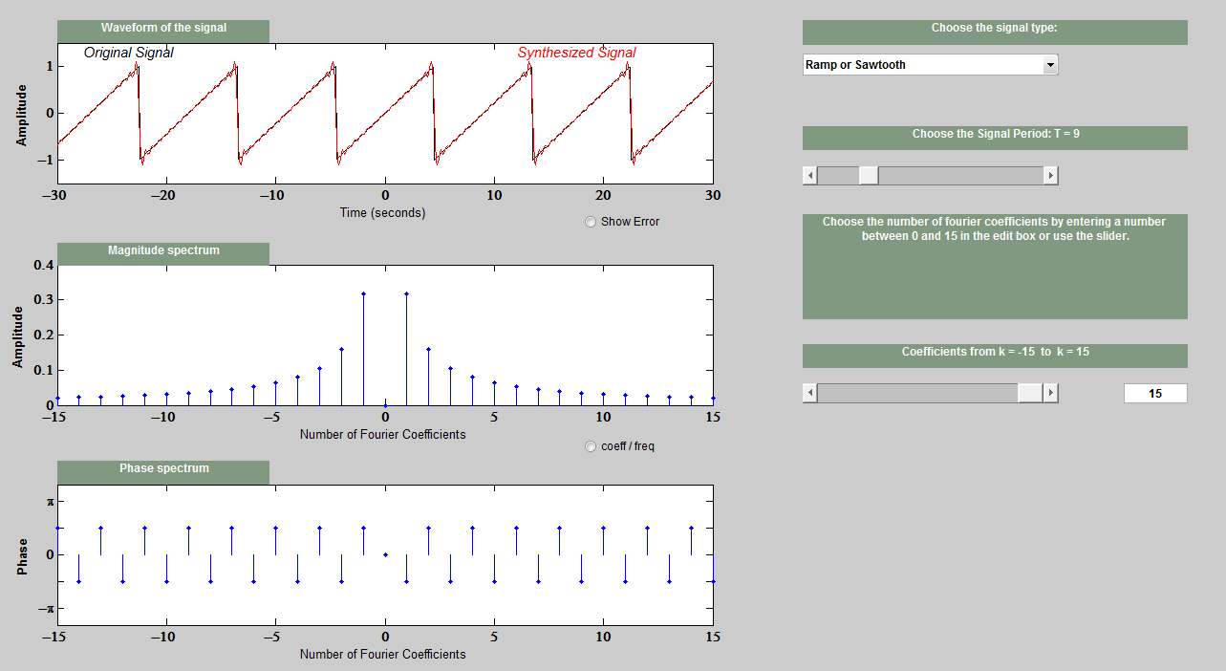

## Half-Rectified Sine Wave

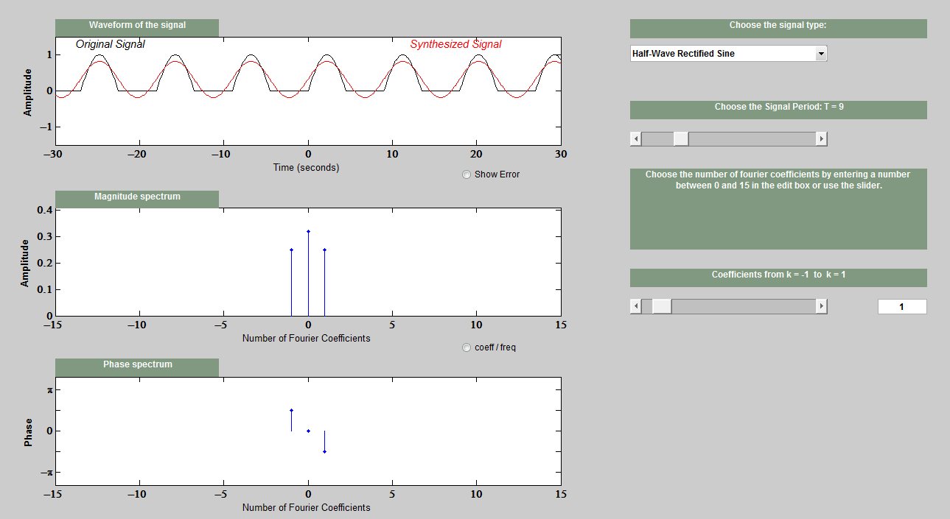

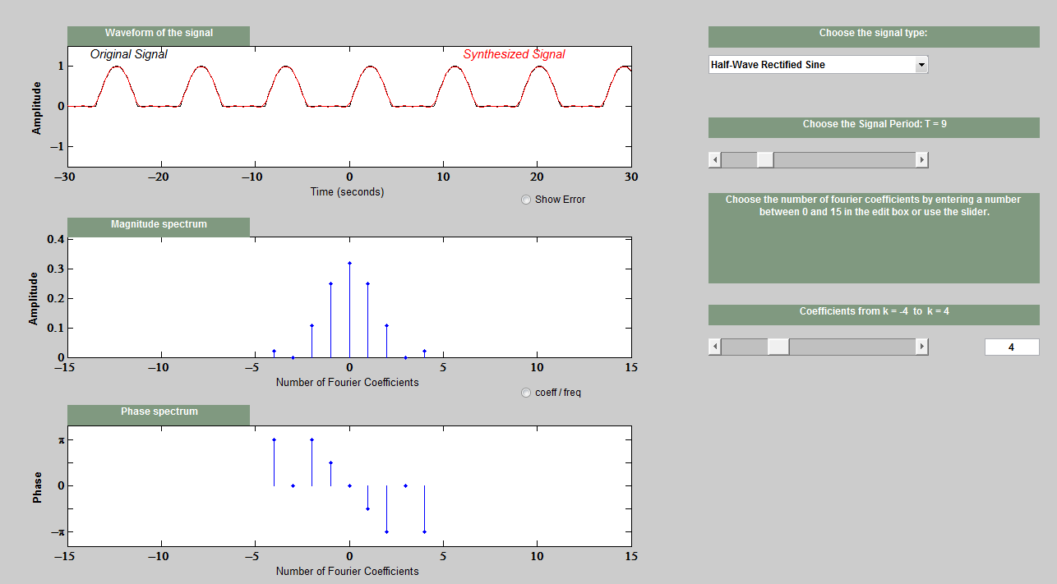

## Full-Rectified Sine Wave

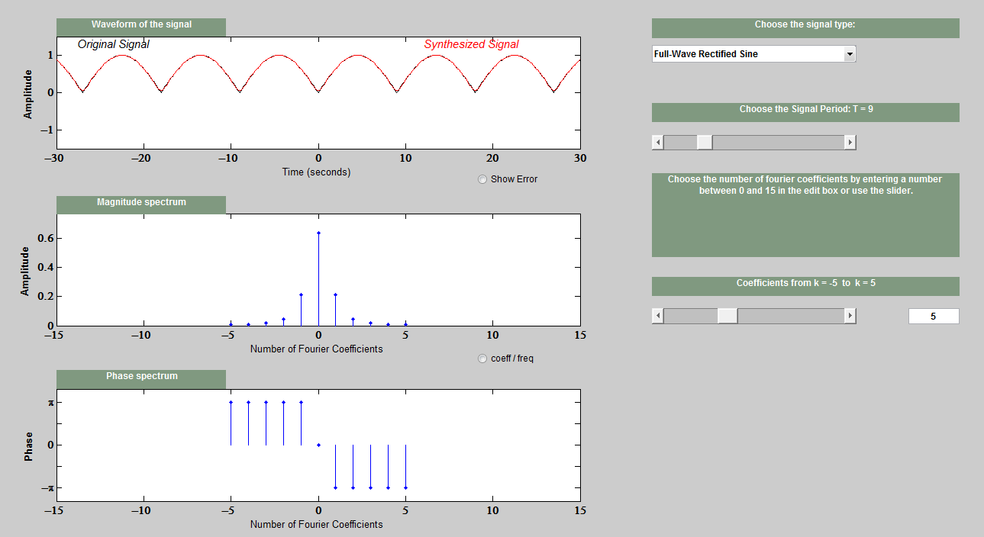

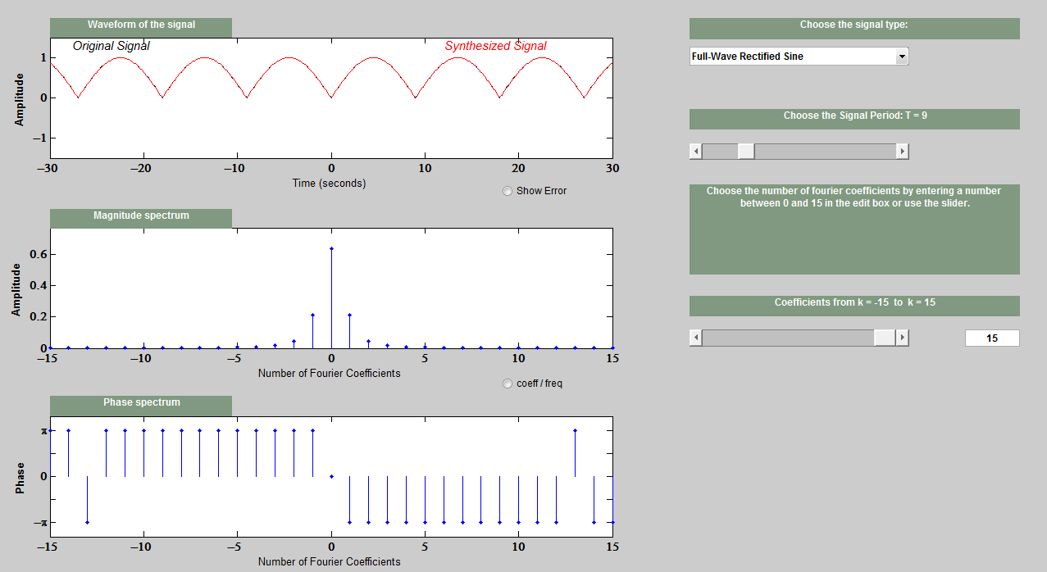

# Appendix B

%% EE 225 Lab 4

%% Fourier Series

clear all

format SHORT

No = 32;

To = pi;

n = linspace(0,pi,No);

x = exp(-n/2);

X_f = fft(x,No);

X_f = [conj(X_f(No:-1:2)),X_f];

X_fmag = abs(X_f);

X_fangle = angle(X_f);

k = -No/2+1:No/2-1;

subplot(211)

stem(k,X_fmag(No/2+1:length(X_f)-No/2))

title('Magnitude')

subplot(212)

stem(k,X_fangle(No/2+1:length(X_f)-No/2))

title('Phase')

%% Fourier Transform

%% Part I

clear all

format short

N_pnts = 100; % t goes from -5 to 5

t0 = linspace(-5,(-1-1/10),N_pnts/2.5);

t1 = linspace(-1,0,11);

t2 = linspace((0+1/10),1,N_pnts/10);

t3 = linspace((1+1/10),5,N_pnts/2.5);

t = linspace(-5,5,101);

x_1 = [0*t0 (t1+1) 1 1 1 1 1 1 1 1 1 1 0*t3];

subplot(311)

plot(t,x_1)

title('Piecewise Linear Function')

xlabel('-5 \leq t \leq 5')

ylabel('Amplitude')

X1 = fft(x_1);

X1 = fftshift(X1);

X1mag = abs(X1);

X1mag = X1mag/max(X1mag); %Normalization

X1angle = angle(X1);

X1angle = X1angle/max(X1angle);

F1 = [-length(X1)/2:(length(X1)/2)-1]*100/length(X1);

subplot(312)

plot(F1,X1mag)

xlabel('f (Hz)')

ylabel('Amplitude')

subplot(313)

plot(F1,X1angle)

title('Phase')

xlabel('f (Hz)')

ylabel('Angle')

%% Part II

clear all

format short

N_pnts = 100; % t goes from -5 to 5

t0 = linspace(-5,(0-1/10),N_pnts/2);

t1 = linspace(0,1,N_pnts/10);

t2 = linspace(1,2,N_pnts/10);

t3 = linspace((2+1/10),5,N_pnts/(10/3));

t = linspace(-5,5,100);

x_2 = [0*t0 (t1) 1 1 1 1 1 1 1 1 1 1 0*t3];

subplot(311)

plot(t,x_2)

title('Piecewise Linear Function')

xlabel('-5 \leq t \leq 5')

ylabel('Amplitude')

X2 = fft(x_2);

X2 = fftshift(X2);

X2mag = abs(X2);

X2mag = X2mag/max(X2mag); %Normalization

X2angle = angle(X2);

X2angle = X2angle/max(X2angle);

F2 = [-length(X2)/2:(length(X2)/2)-1]*100/length(X2);

subplot(312)

plot(F2,X2mag)

xlabel('f (Hz)')

ylabel('Amplitude')

subplot(313)

plot(F2,X2angle)

title('Phase')

xlabel('f (Hz)')

ylabel('Angle')

%% Part III

clear all

format short

N_pnts = 100; % t goes from -5 to 5

t0 = linspace(-5,(-3-1/10),N_pnts/5);

t1 = linspace(-3,3,N_pnts/(5/3));

t2 = linspace(3+1/10,5,N_pnts/5);

t = linspace(-5,5,100);

x_3 = [0*t0 ones(1,60) 0*t2];

subplot(311)

plot(t,x_3)

title('Piecewise Linear Function')

xlabel('-5 \leq t \leq 5')

ylabel('Amplitude')

X3 = fft(x_3);

X3 = fftshift(X3);

X3mag = abs(X3);

X3mag = X3mag/max(X3mag); %Normalization

X3angle = angle(X3);

X3angle = X3angle/max(X3angle);

F3 = [-length(X3)/2:(length(X3)/2)-1]*100/length(X3);

subplot(312)

plot(F3,X3mag)

xlabel('f (Hz)')

ylabel('Amplitude')

subplot(313)

plot(F3,X3angle)

title('Phase')

xlabel('f (Hz)')

ylabel('Angle')

%% Part IV

clear all

format short

N_pnts = 100; % t goes from -5 to 5

t0 = linspace(-5,(-1-1/10),N_pnts/2.5);

t1 = linspace(-1,1,N_pnts/5);

t2 = linspace(1+1/10,5,N_pnts/2.5);

t = linspace(-5,5,100);

x_4 = [0*t0 ones(1,20) 0*t2];

subplot(311)

plot(t,x_4)

title('Piecewise Linear Function')

xlabel('-5 \leq t \leq 5')

ylabel('Amplitude')

X4 = fft(x_4);

X4 = fftshift(X4);

X4mag = abs(X4);

X4mag = X4mag/max(X4mag); %Normalization

X4angle = angle(X4);

X4angle = X4angle/max(X4angle);

F4 = [-length(X4)/2:(length(X4)/2)-1]*100/length(X4);

subplot(312)

plot(F4,X4mag)

xlabel('f (Hz)')

ylabel('Amplitude')

subplot(313)

plot(F4,X4angle)

title('Phase')

xlabel('f (Hz)')

ylabel('Angle')

%% Circuit Anlaysis

%% Sawtooth Wave

clear all

format SHORTE

t = linspace(0,10,100);

sin_val = sin(t);

yDC = 0.5 + sin(t)/pi;

yh = zeros(10,100);

yh(1,:) = yDC;

for k=2:10

yh(k,:) = sin(k*t)/(k*pi);

end

%The Fundemental Frequency

subplot(221)

plot(t,yDC,'b')

title('First Harmonic')

xlabel('t (sec)')

ylabel('V (volts)')

grid on

%The first two harmonics

y2 = yDC + yh(2,:);

subplot(222)

plot(t,y2,'r')

title('First Two Harmonics')

xlabel('t (sec)')

ylabel('V (volts)')

grid on

%The first five harmonics

y5 = yDC;

for k=2:5

y5 = y5 + yh(k,:);

end

subplot(223)

plot(t,y5,'g')

title('First Five Harmonics')

xlabel('t (sec)')

ylabel('V (volts)')

grid on

%The first ten harmonics

y10 = yDC;

for k=2:10

y10 = y10 + yh(k,:);

end

subplot(224)

plot(t,y10,'m')

title('First Ten Harmonics')

xlabel('t (sec)')

ylabel('V (volts)')

grid on

%% Square Wave

t = linspace(0,10,1000);

Amp = 5;

zero = zeros(1,1000);

yh = zeros(10,1000);

for k=1:10

yh(k,:) = (4*Amp/pi)*(1/((2*k)-1))*sin((2*k-1)*t);

end

%The Fundemental Frequency

y = yh(1,:);

subplot(221)

plot(t,y,'r')

title('Fundemental Frequency')

xlabel('t (sec)')

ylabel('V (volts)')

%The first two harmonics

y2 = zero;

for k = 1:2

y2 = y2 + yh(k,:);

end

subplot(222)

plot(t,y2,'r')

title('The First Two Harmonics')

xlabel('t (sec)')

ylabel('V (volts)')

%The first five harmonics

y5 = zero;

for k=1:6

y5 = y5 + yh(k,:);

end

subplot(223)

plot(t,y5,'g')

title('First Five Harmonics')

xlabel('t (sec)')

ylabel('V (volts)')

%The first ten harmonics

y10 = zero;

for k=1:10

y10 = y10 + yh(k,:);

end

subplot(224)

plot(t,y10,'m')

title('First Ten Harmonics')

xlabel('t (sec)')

ylabel('V (volts)')

%% Full-wave Rectified Sine

t = linspace(0,10,1000);

Amp = 2;

yh = zeros(10,1000);

yDC = 2*Amp/pi;

for k=1:10

yh(k,:) = -(4*Amp/pi)*(1/((4*k^2)-1))*cos(4*k*t);

end

%The Fundemental Frequency

y = yDC + yh(1,:);

subplot(221)

plot(t,y,'r')

title('Fundemental Frequency')

xlabel('t (sec)')

ylabel('V (volts)')

%The first two harmonics

y2 = yDC;

for k = 1:2

y2 = y2 + yh(k,:);

end

subplot(222)

plot(t,y2,'r')

title('The First Two Harmonics')

xlabel('t (sec)')

ylabel('V (volts)')

%The first five harmonics

y5 = yDC;

for k=1:6

y5 = y5 + yh(k,:);

end

subplot(223)

plot(t,y5,'g')

title('First Five Harmonics')

xlabel('t (sec)')

ylabel('V (volts)')

%The first ten harmonics

y10 = yDC;

for k=1:10

y10 = y10 + yh(k,:);

end

subplot(224)

plot(t,y10,'m')

title('First Ten Harmonics')

xlabel('t (sec)')

ylabel('V (volts)')

%% Full-wave Rectified Sine

t = linspace(0,10,1000);

Amp = 2;

yh = zeros(10,1000);

y1 = Amp/pi + Amp*sin(4*t)/2;

for k=1:10

yh(k,:) = -(2*Amp/pi)*(1/((4*k^2)-1))*cos(2*4*k*t);

end

%The Fundemental Frequency

y = y1;

subplot(221)

plot(t,y,'r')

title('Fundemental Frequency')

xlabel('t (sec)')

ylabel('V (volts)')

%The first two harmonics

y2 = y;

for k = 1:2

y2 = y2 + yh(k,:);

end

subplot(222)

plot(t,y2,'r')

title('The First Two Harmonics')

xlabel('t (sec)')

ylabel('V (volts)')

%The first five harmonics

y5 = y;

for k=1:6

y5 = y5 + yh(k,:);

end

subplot(223)

plot(t,y5,'g')

title('First Five Harmonics')

xlabel('t (sec)')

ylabel('V (volts)')

%The first ten harmonics

y10 = y;

for k=1:10

y10 = y10 + yh(k,:);

end

subplot(224)

plot(t,y10,'m')

title('First Ten Harmonics')

xlabel('t (sec)')

ylabel('V (volts)')